Fighting Mongoose

Gilberto Lopez

Mason Varias

11/24/14

2nd Iteration

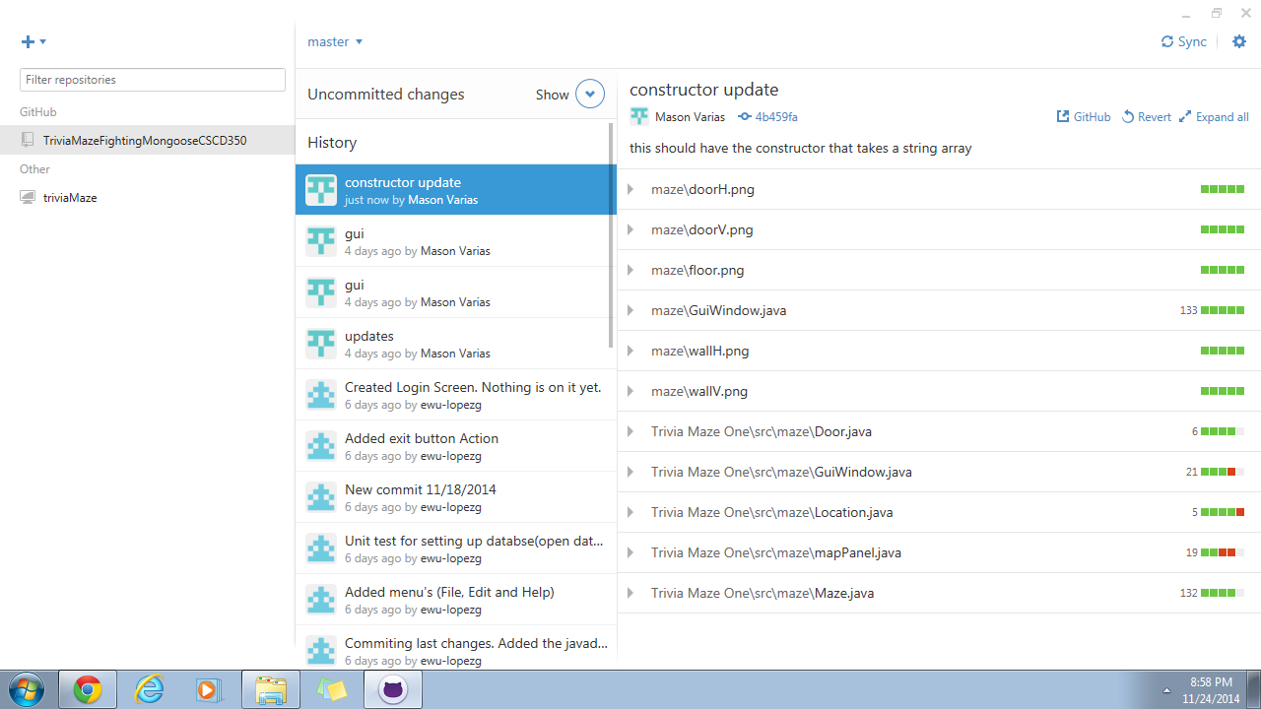

These are the last few pushes that we did.

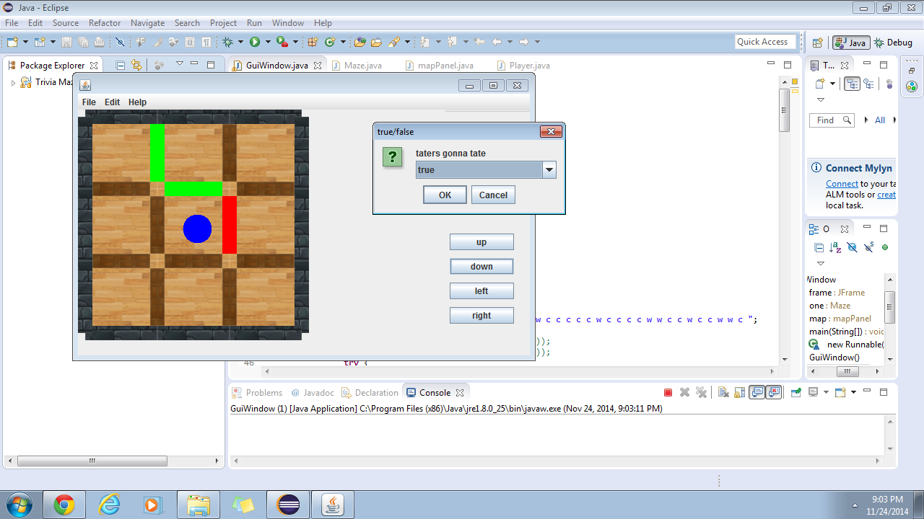

Got a functional gui maze that has movement through doors working as well as the question box popping up.

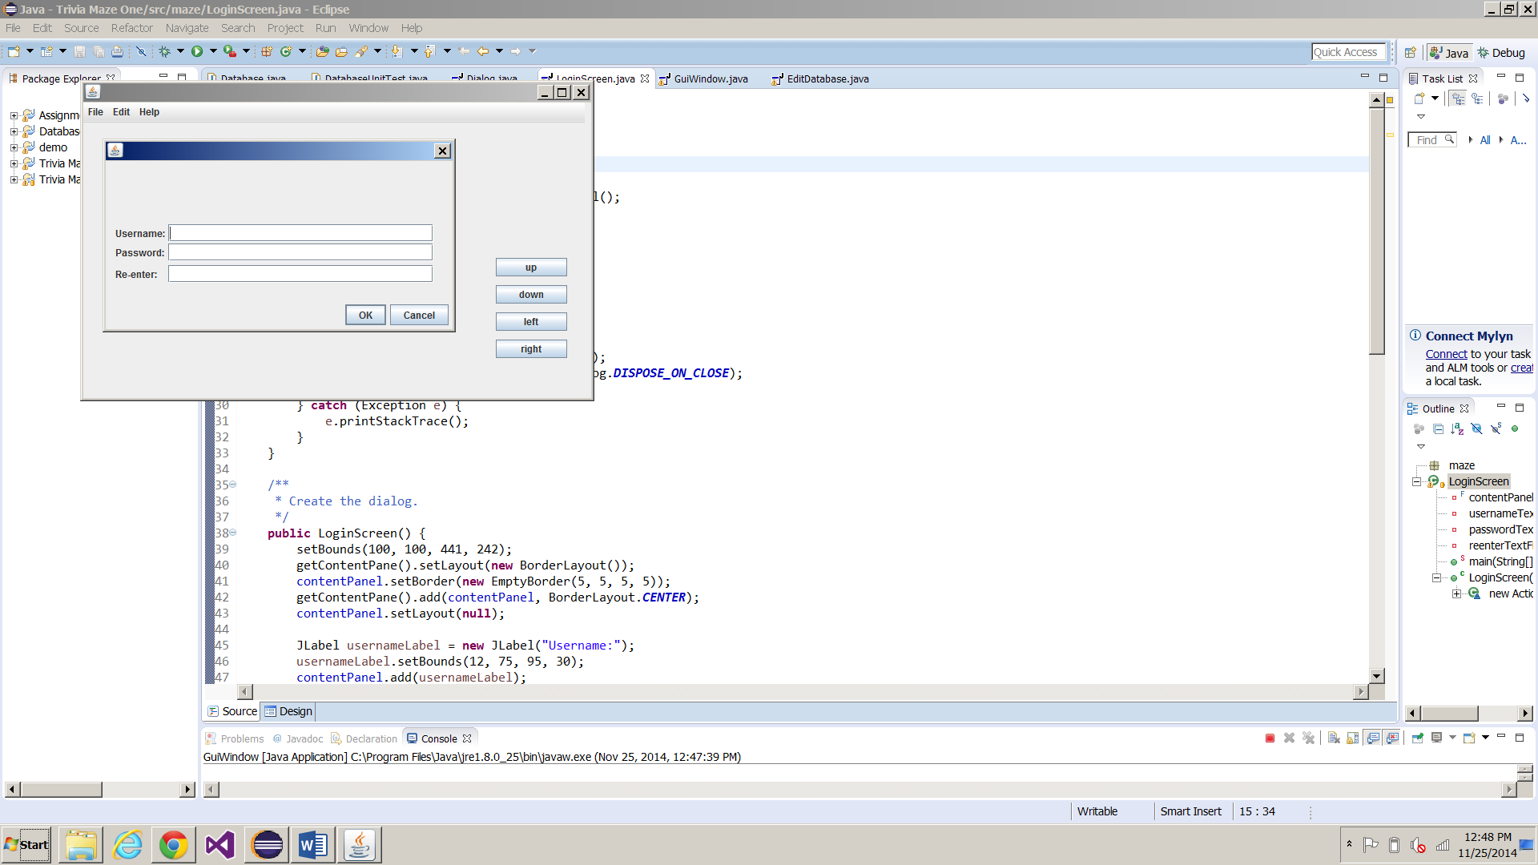

We have our creating new user window up for new users to create their very own profile. This will check to see if the username is already taken.

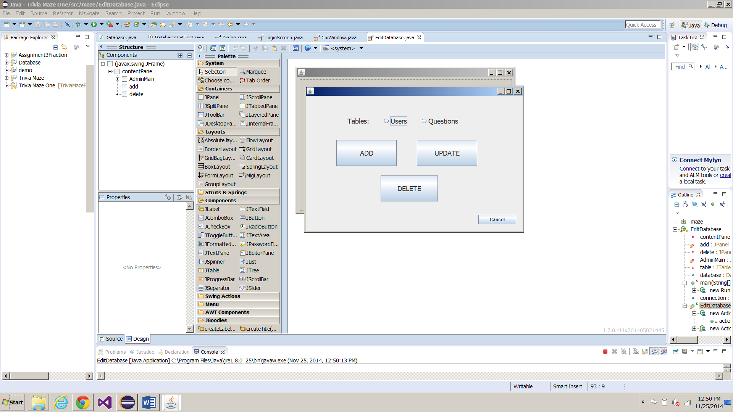

This is the admin window, where he/she can update any table (User or Question).

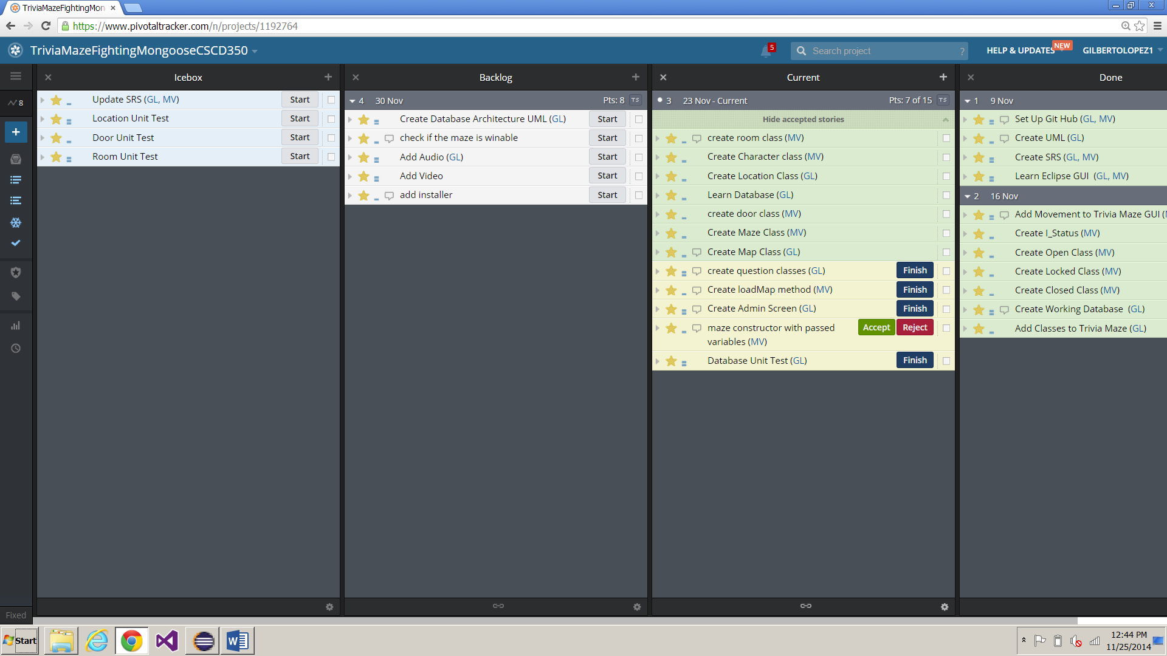

So far our velocity has been 8 points per iteration. As you can see we still have stories on the Icebox and working our way through the backlog and current task.

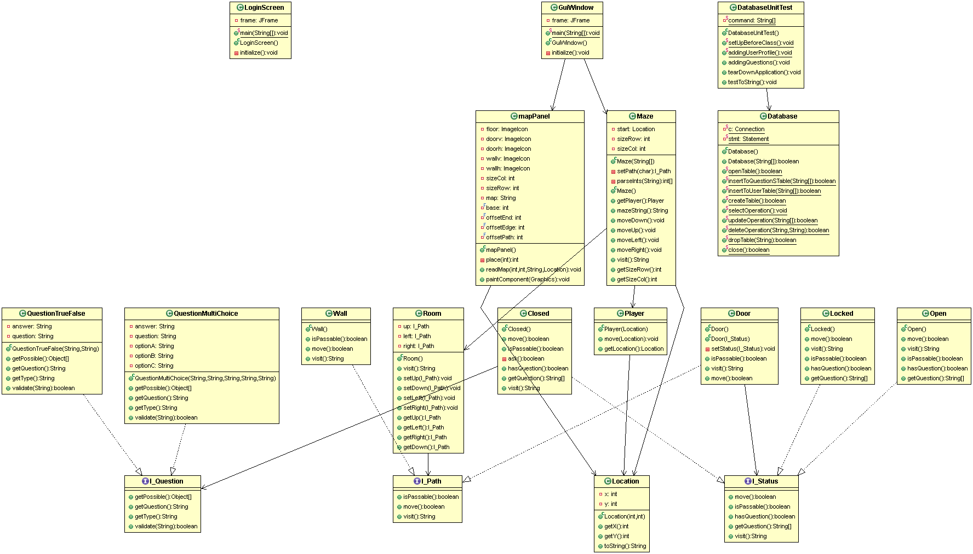

As of now, this is our current class diagram.